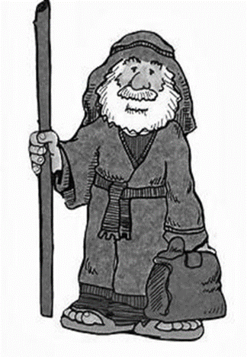

**ME**

“I will make you into a great nation, and I will bless you; I will make your name great, and you will be a blessing.”

Genesis 12:2

**What choices have YOU made?**

**Who do YOU trust?**

**Draw yourself in the box…**

**What choices will you have to make?**

**What words would you use to describe Abraham?**

**ABRAHAM**

**What choices did Abraham make in his life?**

**Who did Abraham trust?**